**COP 1000C Intro Programming Concepts**

**Assignment 5 (Repetition)**

**Part 1 (10 points)** Watch Video Lecture Segments

“08 Repetition”

“09 Logical Operators”

Follow along with the solution to the problems described in Video Segment 08 entering and running them in Visual Studio. The examples demonstrate counter controlled and sentinel controlled while-loops. **Do all of them.** Once done, paste a message in the discussion forum Checkpoint # 1.

**Part 2 (10 points) Evaluate the Relational and Logical expressions in Video Segment 9.8**

Put these expressions in a small program that will demonstrate whether they are true or false. Paste the code, and output from the program into your submission. Use if statements and output a message indicating that the expression is True or False.

#include <stdlib.h>

#include <stdio.h>

main() {

int a = 10, b = 6, c = 4;

if (a <= b || c >= 4) { //TRUE

printf("TRUE");

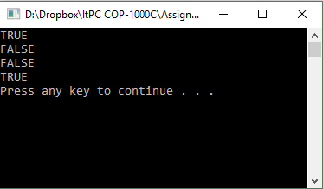 }

else {

printf("FALSE");

}

if (!(a > b)) { //FALSE

printf("TRUE");

}

else {

printf("FALSE");

}

if ( !(b == c) && b >= a) { //FALSE

printf("TRUE");

}

else {

printf("FALSE");

}

if (b == a || c < a && a == 10) { //TRUE

printf("TRUE");

}

else {

printf("FALSE");

}

}

**Part 3 (80 points) Write a C program (with meaningful comments) to solve a problem described in English. Create an IPO.**

We want to count how many passing grades are entered. We don’t know how many grades there will be. Use a sentinel controlled *while* loop that will ask the user to enter student grades until a value of -1 is entered. Use a counter variable to count all the grades that are passing grades, where 70 is the minimum passing grade. If there are any grades that are out of the range 0 – 100, present an error message to the user, and do not count that grade as passing. We also would like to see what percentage of the valid grades are passing.

Create 3 test cases. Use this as one of them:

**Grades Entered: Expected Results**

45

90

70

87

123 “That is not a valid grade!”

100

-1 You entered 4 passing grades.

80.0% of the valid grades entered are passing grades.

#include <stdlib.h>

#include <stdio.h>

main() {

printf("--------------------------\n");

printf(" - Grade Data Entry - \n");

printf("--------------------------\n\n");

printf("Directions: Enter grades from 1 - 100, followed by pressing 'Enter'. Enter '-1' to complete data entry.\n\n");

printf("Enter Grade(s):\n");

int counter = 0;

int grade, passingGrade = 0;

double passingPerc;

do { // Do-While chosen to set 'grade' value

scanf_s("%i", &grade); // before first loop condition check.

if (grade >= 0 && grade <= 100) {

counter++;

if (grade >= 70)

passingGrade++;

}

else {

if(grade != -1) // Exclude -1 from main if-condition to

// prevent incrementing 'counter'.

printf("\nInvalid grade! Please re-enter value.\n\n");

}

} while (grade != -1);

printf("\nData entry complete.\n\n");

if (counter != 0) {

passingPerc = (passingGrade / (double)counter); // Type-cast //'counter' to double // to give percentage // as decimal < 1.

passingPerc *= 100; // Transform to percentage.

}

else {

passingPerc = 0.0; // Set to 0.0 to prevent divide by 0 answer.

printf("No grade(s) entered.\n\n");

}

printf("--------------------------\n");

printf(" - Result(s) - \n");

printf("--------------------------\n\n");

printf("Passing Grade(s): %i (of %i) | %.1lf%%\n", passingGrade, counter, passingPerc);

system("pause");

}

|  |  |  |
| --- | --- | --- |
| INPUT | PROCESS | OUTPUT |
| grade | **Check if valid grade; valid grades++** |  |
|  | **If (!valid grade)** | **“Invalid Grade”** |
|  | **Check if passing; passing grades++** |  |
|  | **Calculate passing percentage** | **Passing grades out of valid grades & percentage of passing grades** |

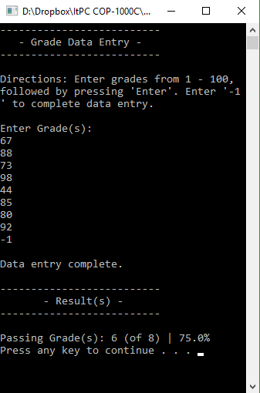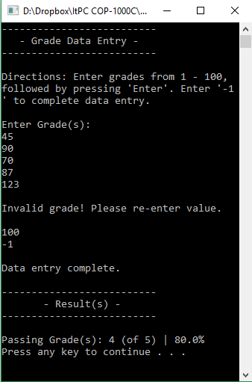

|  |  |
| --- | --- |
| Input | result |
| 67 |  |
| 88 |  |
| 73 |  |
| 98 |  |
| 44 |  |
| 85 |  |
| 80 |  |
| 92 |  |
| Passing | **6 / 8 | 75%** |

|  |  |
| --- | --- |
| Input | result |
| 70 |  |
| 43 |  |
| 55 |  |
| 87 |  |
| 90 |  |
| 105 | **INVALID** |
| 112 | **INVALID** |
| 136 | **INVALID** |
| 16542 | **INVALID** |
| 23 |  |
| PASSING | **3 / 6 | 50%** |

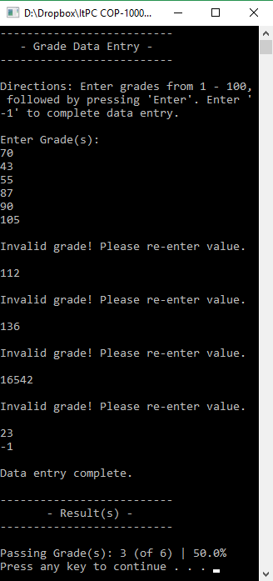

**Deliverables:** Paste code, program output and screen shots into this Word document.

Presenting your solution is part of the assignment.

1. The message posting once part 1 is done. (10 points)
2. Solution to Part 2 (paste code and screen shot/s of the output window) – solution to the relational/logical expressions. (10 points)
3. An IPO for the problem in Part 3.(10 points)
4. Two test cases that show two sets of input data, and the expected results of running the program for each set of input data. These are to be written separately before running the program and taking the screen shots. ( 6 points)
5. The code that solves the passing grades problem. Remember to use meaningful comments. (55 points)
6. Output from running the program 3 different times. Use two test cases that you created and the one I have given you. (9 points)

**Things to do when you’re stuck:**

Post messages on the discussion board

Send email to the instructor

Go and visit the tutor during his hours

Call or visit the instructor during her hours